

FBOG Autumn 2025 Newsletter

Chairmans Welcome – Andrew Cottrell
Autumn is always an exciting time in the birding year, and this year it has been especially true as two “First for Filey” birds have been recorded - read about their exciting discoveries below.
Unsurprisingly, there has been a lot of activity on our WhatsApp Bird Sightings group and I would like to give a personal shout out to all those regular contributors that keep the rest of us so well informed - I won’t name names, but you know who you are - Thank You.
At the end of this newsletter we have added a new section to make you all aware of any upcoming events. Of particular note in this issue is the FBOG Annual General Meeting. This will take place in The Committee Room of Filey Golf Club on Saturday November 15th starting at 4pm. Members are welcome to attend. If you do plan to come along I would appreciate it if you would drop me a quick text or WhatsApp to let me know (07503 579424).

Sighting Summary July - Oct 2025 - George Watola
An incredible autumn at Filey, with two Firsts for Filey turning up. A Brown Shrike at Hunmanby Gap in late September was a surprise, considering we have never had an Isabelline type, ever. An even better bird, White-throated Needletail, hung around Carr Naze after being seen at Bempton Cliffs the previous day. It drew a considerable crowd very quickly.
Pink-footed Geese and Whooper Swans migrated south as usual in the autumn, but a surprise was the hundreds of Barnacle Geese (530) that flew over on 13th October, doubling the previous day-record. Two Ruddy Shelduck flew south on 10th October.
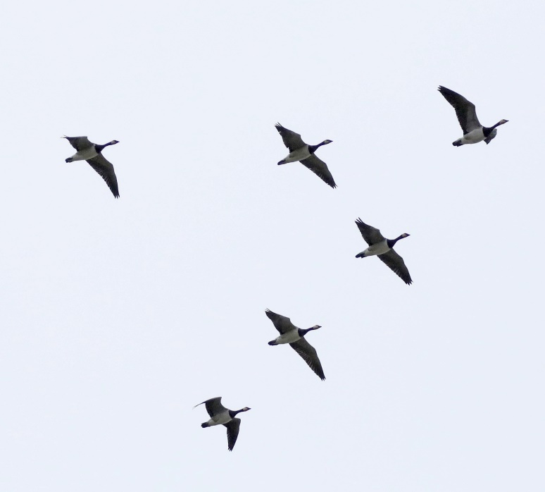

Barnacle Geese, Carr Naze, October 2025. Photo: John Harwood

A lot of waders visited during the summer, with Wood Sandpiper, Black-tailed Godwits, Little Ringed Plover, Green Sandpiper, Ruff, Little Stint, Grey Plover, Spotted Redshank and Greenshank being notable. A Turtle Dove was discovered in a garden shed at Hunmanby Gap on 4th September. Occasional Caspian Gulls were seen, but no Yellow-legged Gulls mysteriously. Black and Roseate Tern were seen in September. A Little Auk was reported in August in a garden, but this record seems too good to be true? Great White Egret were frequently seen flying over, to where?
A twitchable Cattle Egret finally lingered in August for 13 days at East Lea. Four Glossy Ibis did not stay on 6th October, part of the nationwide invasion. Another flew south on 9th. A Hen Harrier flew south on 11th October. A rare, for Filey, Kingfisher was flushed from rocks in Bay corner in August. The autumns first passerine scarcity, a Barred Warbler, was briefly in cliff top bushes just south of Martins Ravine on 21st August.
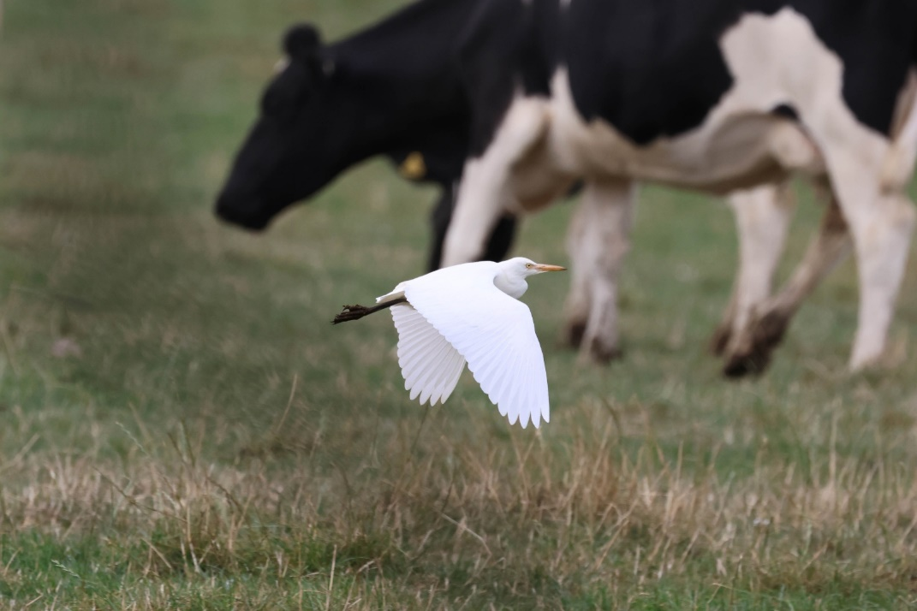

Cattle Egret, East Lea Fields, August 2025.
Photo: Ian Robinson

On 18th September an unforgettable morning at Hunmanby Gap with nearly 10,000 birds passing including a record 4,300 House Martins plus over 1,000 Siskin and 3,000 Meadow Pipits. Yellow-browed Warbler, an autumn favourite, began to turn up from late September. On October 20th four Yellow-browed Warblers were on the patch (two St Oswald’s, one Long Lane and one Parish Wood). Also on this day a Firecrest was recorded in Parish Wood and a late Willow Warbler was in Top Scrub.

Brown Shrike Discovery - Keith and Clare Clarkson
Hunmanby Gap is located at the head of Filey Bay and has some wonderful scrub, sheltered in the lea of the soft cliffs, that would appear to be a perfect landing place for rare migrants arriving across the North Sea. However, since moving here in 2008 that promise has not really been fulfilled. However, on the afternoon of 25th September, 2025, all that changed.
Clare and I were walking back, through the clifftop scrub, hearing several Goldcrest alarming, we stopped. Scanning through the bushes I picked up a ‘tack-ing’ Lesser Whitethroat. What was the threat? Searching backwards and forwards I couldn’t see anything obvious, until, lurking in the shadows, the ‘mask of Zorro’!
I literally couldn’t believe my eyes, in the cover of the thorn-bush, the ill-defined shape of a large-billed shrike with a striking black eye-mask, bordered by a broad white supercilium, forehead and cheeks. It had a uniformly, rusty brown crown, mantle and long-thin tail contrasted with rich gingery-brown rump and uppertail coverts, warm apricot breast and flanks, with white chin and belly. I knew we had either an adult male Brown Shrike or one of the Red-tailed Shrikes but without a camera, more powerful optics and with no phone reception I was struggling to nail it or put out the news.
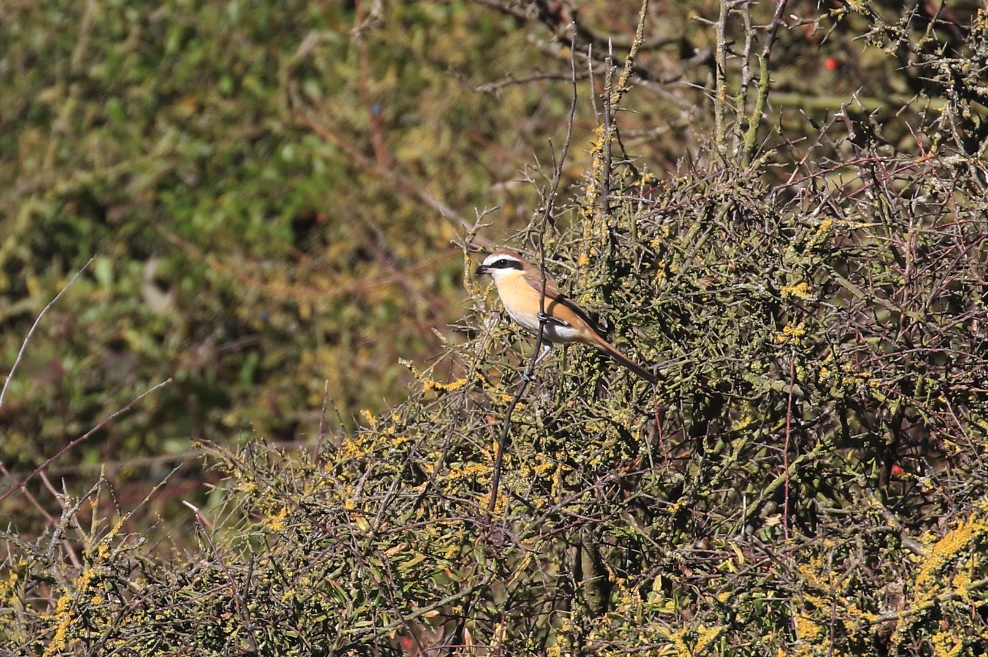

Brown Shrike Lanius cristatus cristatus, adult male, Hunmanby Gap 25th September 2025.
Photo: Keith Clarkson

I legged it home, grabbed my camera and scope, put the news out and ran back. After a short while the bird reappeared - perfectly framed in the afternoon sun. Although the primaries and greater coverts were edged-pale there was no white patch at the base of the primaries. I was confident it was a Brown Shrike, an identification confirmed by the dozens of birders who turned up in the next few hours.
If accepted, this will be the sixth record for Yorkshire and the first for the Filey recording area. Remarkably, three records have been reported, just down the road, from the Flamborough Headland including one also seen on the 25th September, in 2008.

White-throated Needletail Sighting - Chris Stevenson
As new members we joined our first FBOG social at The Cobblers on Wednesday 8th. A lot of chat was about the incredible discovery of the White-throated Needletail, initially at Top Hill Low and then at RSPB Bempton. This was only the second ever record in Yorkshire and the first since 1991!
The White-throated Needletail (Hirundapus caudacutus) is a large, stocky swift with a long, sabre-shaped wing span of 50-54cm. The Needletail has a bullet-like body, and a square-cut tail tipped with stiff, spine-like feathers that give the species its name.

The next afternoon as I set off on my afternoon dog walk the last thing on my mind was re-locating this rarity. My primary aim was to try and see the Bottlenose Dolphin that had been recently reported.

Walking along, I was late to notice a bird approaching across the bay from the south. It passed above me and headed northwards at speed before I could get an ID. However, it was definitely a swift like bird, it just didn’t seem quite right! I continued to walk to the end of the Brigg and as I was turning back, I noticed the bird had reappeared and was circling close in a large figure of eight. It was clear now that this ‘swift’ had a white-throat and white patch beneath the tail and seemed stockier than the Common Swift (Apus apus). I quickly realised that I was looking at the bird we had been talking about the previous evening.

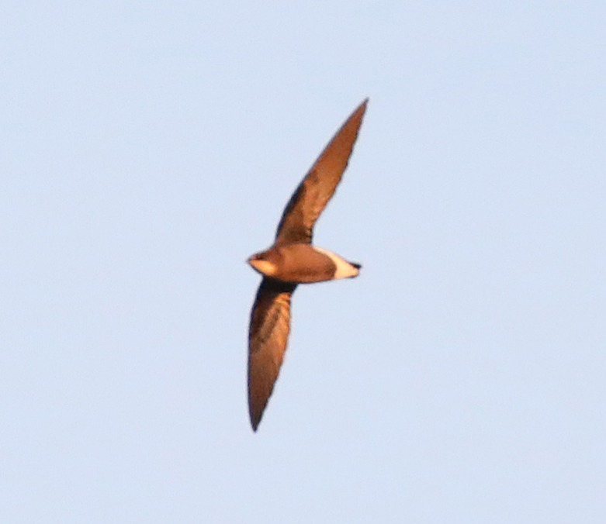

White-throated Needletail, Carr Naze, October 2025.
Photo: John Harwood

Luckily, I had been added to the FBOG WhatsApp group on Monday and was able to make my first ever report to the group members. ‘White-throated Needletail Brigg.’ I realise now that I probably should have been a bit more specific as it led to lots of people having to ask for clearer details! However, it was good to see a steady stream of birders arriving, most of whom were lucky enough to get some good views and pictures.

The moral of the story, join FBOG and find a first for Filey! I think it may be some time before I find such a rare bird again.

Autumn Ringing Review – Kieran Foster, Merseyside Ringing Group
In early September 2025 I checked out the “opportunities for ringers” page on the BTO website. I was looking to see if there were any opportunities for my trainees. I noticed a request for help ringing at Filey Bird Observatory. Being based in St Helens, Merseyside, wasn’t ideal, but the chance to ring on the east coast in the autumn wasn’t going to come along too often and I figured that if the weather was poor over in my usual ringing site, it might be good at Filey.
The chance of something different to my usual site and the additional experiences for my T permit holders would hopefully make the 260-mile round trip worth it.
I dropped a quick email and was happy to receive a reply from Lucy, Ringing Officer, offering me the chance of ringing in Top Scrub over the autumn. After a few emails back and forth and a telephone conversation, arrangements were made to make a first visit on the 14th September. I expected to have to do quite a bit of work to open the rides up as I had been informed that there hadn’t been much ringing done for a couple of years. I was then told a few days before that an FBOG work party had been in and cut some of the rides, and some guy strings had been left, along with poles put in by Lucy for me to use, which was fantastic news and very much appreciated.
I collected the rings at 0730 and made my way to the Top Scrub. After a walk through, with detailed notes from Lucy, Jasmine and I set a few nets with the view that we would see what happens. Lucy arrived a little later in the morning and walked us through the rest of the rides. The session finished with 38 birds ringed including a lovely Lesser Whitethroat. It was great to be warmly welcomed by Sid and Mike, in addition to Lucy during this first visit.
Lucy discussed with Mike a few other rides which could do with clearing and Mike, along with a team of volunteers, carried this out the following week. The next visit (due to weather) was over the weekend of the 27th and 28th September. We arrived about 9pm on the 26th. Several nets were set and furled overnight so that there would be a few nets up before dawn and this would mean we could get the other nets up in the light while these nets could already be catching. The Saturday went well with 67 birds being handled. The final bird of the session was a British control Chiffchaff. This bird had been ringed at South Milton Ley NR, Devon on 30th October 2024.
Unfortunately, the weather overnight turned to rain, and although this was predicted to have stopped by dawn, it persisted until about 0930. The late start only resulted in 12 new birds on the 28th with an additional 5 from the 27th, but another British control. This time a Treecreeper which had been ringed at RSPB Bempton Cliffs on 16th August 2025.
Sadly, the weather at the weekends in October wasn’t particularly conducive to ringing and we only managed to have a session on the 12th. This produced an additional 44 new birds and four re-traps. The new birds did include two male Sparrowhawk which was nice.
The welcome we have received by FBOG was very kind and generous. It was unfortunate that we didn’t manage to catch anything unusual to repay the work that was put into the rides by so many people. Hopefully this will come in the spring and autumn 2026 if you are happy to have us back.

The table below shows the total birds recorded across the four sessions

Species | New | Re-trap / control
Blackbird | 2
Blackcap | 2
Blue Tit | 22 | 2
Chaffinch | 10
Chiffchaff | 11 | 1
Coal Tit | 5
Dunnock | 6 | 2
Goldcrest | 33 | 3
Goldfinch | 1
Great Spotted Woodpecker | 1
Great Tit | 13
Greenfinch | 12
Lesser Whitethroat | 1
Long-tailed Tit | 15
Reed Bunting | 3
Robin | 5 | 1
Siskin | 1
Song Thrush | 1
Sparrowhawk | 2
Stonechat | 1
Treecreeper | 1 | 1
Willow Warbler | 5
Wren | 7 | 1
Total | 160 | 11

Reserve Maintenance and Upgrades - Mike Cole
The following projects have been completed over the course of the Summer 2025 through several work parties. It is gratifying to note that we have a good band of volunteers that make all this possible. If you think you could help out too, then please join the Work Party Group in the FBOG Community WhatsApp, as everything is arranged there.
East Lea
- A new bird feeding station was constructed near the East Lea Hide with removal of the older ones. A bench was installed from which to view the feeders.
- The access path to the hide was widened for safer access.
- A small platform was built at the viewing screen between the kissing gates to allow a better viewing experience for all.
- Repairs to the boardwalk bridge.
- Regular mowing and maintenance of the whole access path to East Lea.
- The reedbed scrape was mown to keep down the phragmites.
- The drought conditions reduced the number of wader species visiting East Lea but it did provide an opportunity for us to access the islands and remove most vegetation before Winter.
- A handrail has been constructed alongside the access steps at the gate.
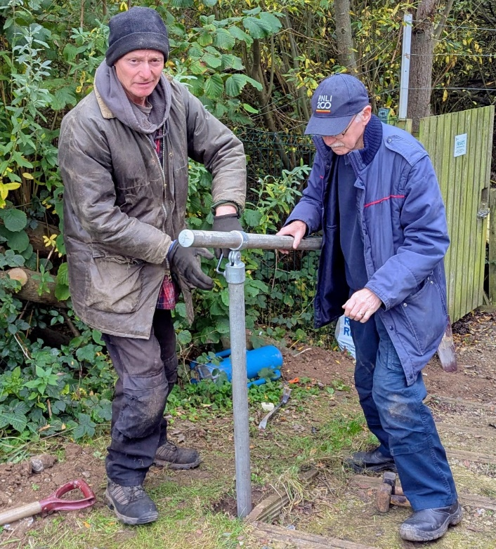

Paul and Mark erecting the new handrail, October 2025

Old Tip and Top Scrub
- The vegetation around the Heligoland trap was pruned and managed in preparation for potential ringers to use.
- Extensive cutting back was undertaken around the top scrub pond and in the top scrub itself to renovate and prepare ringing lanes. The hard work required has now paid dividends as we have ringing teams from Merseyside and York now using this facility. Thank you to all who took part in this project.
- Groundwork repairs to fence and gate posts were required in Parish Wood and the Old Tip. The exceptionally dry season shrank the clay, resulting in loose posts.
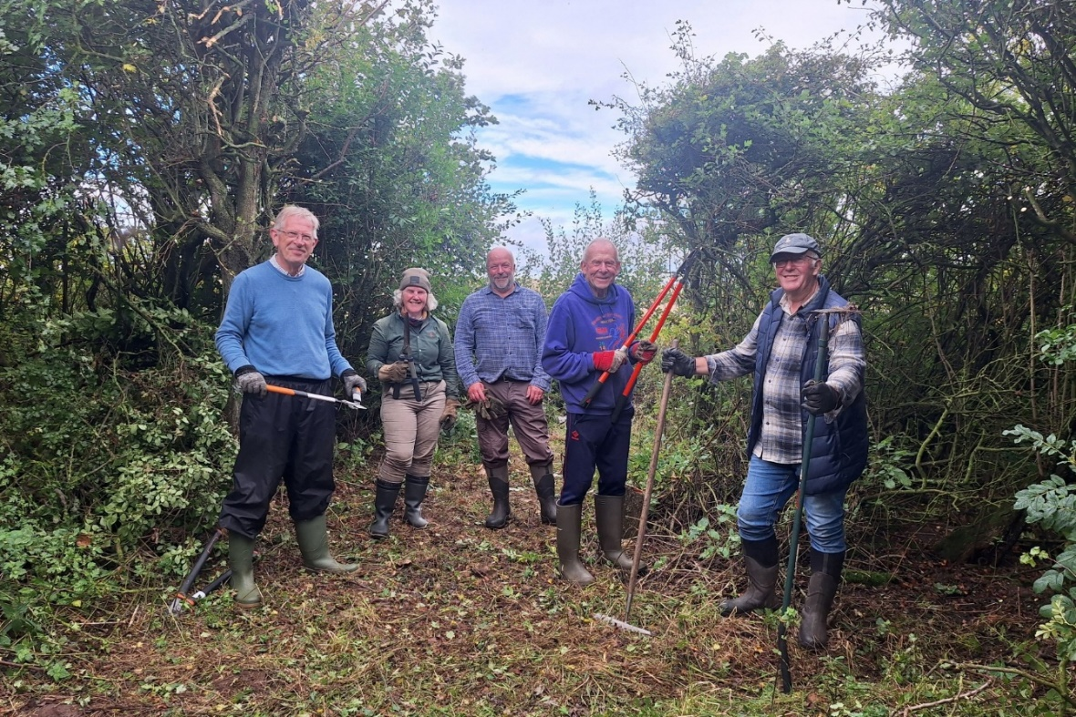

Mike, Sandra, Nick, Steve and Kev cutting ringing lanes, Top Scrub, September 2025

Future works in consideration include a new gatepost in Parish Wood, design and construction of viewing screens at either end of the reedbed scrape at East Lea and a mixed hedge to be planted behind the East Hide as screening. In time this should prevent birds being flushed from the field surrounding East Lea.
I am delighted that we have had a visit from a school at Brompton who have raised a number of saplings and have brought them to East Lea. These will form part of the new hedge. A group of pupils will be involved in their planting. The involvement of school children is a most welcome and important step in the development of our future naturalists.

Filey Dams Maintenance Work - Kate Yates, YWT
In November we are undertaking some long-awaited maintenance of the pond and scrape areas at Filey Dams, and during this time there will be inevitable disturbance as heavy machinery will be working on site. We have planned 3 days in the first week of November, but as ever we are at the mercy of the weather so this may be subject to last minute change.
The work will be taking place on the scrape area in front of the central hide, and the pond area behind Silverwood Avenue. We are doing this work to maintain the variety of wet habitats and associated wildlife which can be found at Filey Dams.
In the scrape our focus will be ensuring the area can hold water for longer, therefore extending the period of drawdown and provision of the muddy margins. This will be done in three ways.
- Repair erosion damage along the existing margin.
- Remove accumulated surface vegetation and silt from scrape bed, reinstating uneven profile and pools.
- Reinstate the profile of the existing bund between the scrape and the main pool.
Our work in the pond area is to maintain good habitat for Great crested newt and Water vole, as well as pond/riparian assemblages. We will reinstate open water and pond edge habitat by removing the accumulation of silt and vegetation, leaving at least 50% of the pond edge completely undisturbed. This is phased maintenance so will be repeated in the next few years until we have worked our way around the entire pond.
Please be assured we are doing everything we can to minimise the impact on wildlife while this work is taking place. We are following best practice guidance for pond management, have carefully considered timing of the operations, and are taking precautionary measures to safeguard protected species on the reserve by undertaking a hand search and advance clearing machinery access routes, for example.
We have been supported by your fellow members in organising this work, Thank you to Ian and George particularly for your help. I hope that we will have your support too, but if you have any questions, please do get in touch with me on the contact details below.
Kate Yates, Nature Reserves Manager. 07825 668 415 / kate.yates@ywt.org.uk

FBOG In The Running For A Tescos “Stronger Starts” Grant - Andrew Cottrell
If you shop in Filey Tesco then please consider adding your blue tokens to our project. Our plan is to upgrade the bird feeding station at Filey Dams to create an educational engagement for families. Our focus is to spark greater enthusiasm for our garden birds by providing additional identification boards and, importantly, information on how to safely feed birds in the garden to prevent the spread of disease.

Dates for your calendar

What | Where | When
FBOG Annual General Meeting | The Committee Room, Filey Golf Club | November 15, 4pm
Work Party | The Dams Car Park | November 5, 9.30am
Work Party | The Dams Car Park | December 3, 9.30am
Work Party | The Dams Car Park | January 7, 9.30am
Work Party | The Dams Car Park | February 4, 9.30am
Work Party | Other reserves | Join FBOG Work Party WhatsApp group to be informed
Social Gathering | The Cobblers, Filey, Back Room | November 12, 7pm
Social Gathering | The Cobblers, Filey, Back Room | December 10, 7pm
Social Gathering | The Cobblers, Filey, Back Room | January 14, 7pm
Social Gathering | The Cobblers, Filey, Back Room | February 11, 7pm

